Simple Grant Application Form
For projects equal to or less than USD$1,000

Regional Location:
Project based in which Caribbean country

Date of Grant Application

Organization Information:
Organization Name
Contact Person
Contact Email
Contact Phone (WhatsApp)
Mailing Address

Organization Website

Project Details:
Project Title
Project Description (max 100 words)
Project Start Date
Project End Date

Financial Information:
Total Project Budget (in US$)
Amount Requested from Caribbean Ocean Trust
Sources of Other Funding (if any)
[Please specify any other funding sources contributing to this project.]
Marine Conservation Focus:
Describe how your project aligns with marine conservation goals and contributes to the protection and preservation of marine ecosystems (max 100 words):

Declaration: I, the undersigned, certify that the information provided in this grant application is true and accurate to the best of my knowledge. I understand that any false or misleading information may result in the rejection of this application.
Signature: _________________________ Date: _______________

Submission Instructions: Please submit this completed grant application form (as a pdf) along with any required attachments to Grants@CaribbeanOceanTrust.org
For any questions or additional information, please use the same email address above.

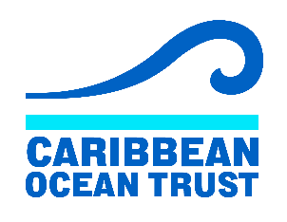
https://caribbeanoceantrust.org

